Chapter 14: Inference for Distribution of Categorical Variables: Chi-Square Procedures

Objectives: Students will:
Explain what is meant by a chi-square goodness of fit test.
Conduct a chi-square goodness of fit test.
Given a two-way table, compute conditional distributions.
Conduct a chi-square test for homogeneity of populations.
Conduct a chi-square test for association/independence.
Use technology to conduct a chi-square significance test.

AP Outline Fit:
IV. Statistical Inference: Estimating population parameters and testing hypotheses (30%–40%)
B. Tests of significance
6. Chi-square test for goodness of fit, homogeneity of proportions, and independence (one- and two-way tables)

What you will learn:

- Choose the Appropriate Chi-Square Procedure
  - For goodness of fit tests, use percents and bar graphs to compare hypothesized and actual distributions.
  - Distinguish between tests of homogeneity of populations and tests of association/independence.
  - Organize categorical data in a two-way table. Then use percents and bar graphs to describe the relationship between the categorical variables.
- Perform Chi-Square Tests
  - Explain what null hypothesis is being tested.
  - Calculate expected counts.
  - Calculate the component of the chi-square statistic for any cell, as well as the overall statistic.
  - Give the degrees of freedom of a chi-square statistic.
  - Use the chi-square critical values in Table D to approximate the P-values of a chi-square test.
- Interpret Chi-Square Tests
  - Locate expected cell counts, the chi-square statistic, and its P-value in output from computer software or a calculator.
  - If the test is significant, use percents, comparison of expected and observed counts, and the components of the
chi-square statistic to see which deviations from the null hypothesis are most important.
Section 14.1: Test for Goodness of Fit

Knowledge Objectives: Students will:
Describe the situation for which the chi-square test for goodness of fit is appropriate.
Define the χ² statistic, and identify the number of degrees of freedom it is based on, for the χ² goodness of fit test.
List the conditions that need to be satisfied in order to conduct a test χ²for goodness of fit.
Identify three main properties of the chi-square density curve.

Construction Objectives: Students will be able to:
Conduct a χ² test for goodness of fit.
Use technology to conduct a χ² test for goodness of fit.
If a χ² statistic turns out to be significant, discuss how to determine which observations contribute the most to the total value.

Vocabulary:
Statistics –

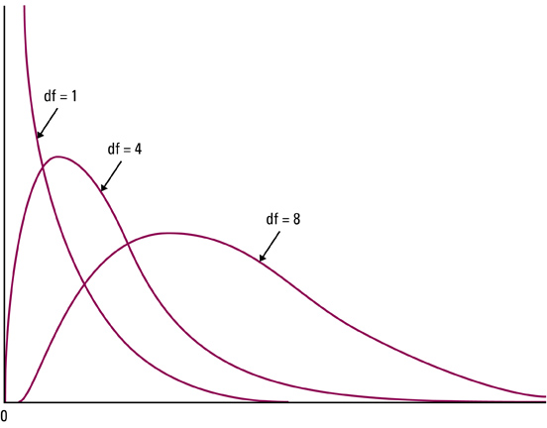
Key Concepts:

Chi-Square Distribution:
- Total area under a chi-square curve is equal to 1
- It is not symmetric, it is skewed right
- The shape of the chi-square distribution depends on the degrees of freedom (just like t-distribution)
- As the number of degrees of freedom increases, the chi-square distribution becomes more nearly symmetric
- The values of χ² are nonnegative; that is, values of χ² are always greater than or equal to zero (0); they increase to a peak and then asymptotically approach 0
- Table D in the back of the book gives critical values
Goodness-of-fit test Conditions:
- All expected counts are greater than or equal to 1 (all E_{i} ≥ 1)
- No more than 20% of expected counts are less than 5
Remember it is the expected counts, not the observed that are critical conditions

Example 1: Are you more likely to have a motor vehicle collision when using a cell phone? A study of 699 drivers who were using a cell-phone when they were involved in a collision examined this question. These drivers made 26,798 cell phone calls during a 14 month study period. Each of the 699 collisions was classified in various ways.
Sun | Mon | Tue | Wed | Thu | Fri | Sat
20 | 133 | 126 | 159 | 136 | 113 | 12
Are accidents equally likely to occur on any day of the week?
a) Do a graphical analysis (with a bar chart) using your calculator

b) Using a chi-square goodness of fit test

- Hypotheses:

- Conditions:

- Calculations:

- Interpretation:

Example 2: Does either the large bag or the small bag of M&M’s fit the distribution of Peanut M&M’s?
 | Yellow | Orange | Red | Green | Brown | Blue | Totals
Sample 1 | 66 | 88 | 38 | 59 | 53 | 96 | 400
Sample 2 | 10 | 9 | 4 | 16 | 9 | 7 | 55
Peanut | 0.15 | 0.23 | 0.12 | 0.15 | 0.12 | 0.23 | 1
Plain | 0.14 | 0.2 | 0.13 | 0.16 | 0.13 | 0.24 | 1
 | K = 6 classes (different colors)
 |  | CS(5,.1) | CS(5,.05) | CS(5,.025) | CS(5,.01)
 |  | 9.236 | 11.071 | 12.833 | 15.086

a) Large Bag

- Hypotheses:

- Conditions:

- Calculations:

- Interpretation:

b) Small Bag

- Hypotheses:

- Conditions:

- Calculations:

- Interpretation:

Homework: pg 846 14.1 – 14.6, 14.8
Section 14.2: Inference for Two-Way Tables

Knowledge Objectives: Students will:
Explain what is mean by a two-way table.
Define the chi-square (χ²) statistic.
Identify the form of the null hypothesis in a χ² test for homogeneity of populations.
Identify the form of the null hypothesis in a χ² test of association/independence.
List the conditions necessary to conduct a χ² test of significance for a two-way table.

Construction Objectives: Students will be able to:
Given a two-way table, compute the row or column conditional distributions.
Using the words populations and categorical variables, describe the major difference between homogeneity of populations and independence.
Given a two-way table of observed counts, calculate the expected counts for each cell.
Use technology to conduct a χ² test of significance for a two-way table.
Discuss techniques of determining which components contribute the most to the value of χ².
Describe the relationship between a χ² statistic for a two-way table and a two-proportion z statistic.

Vocabulary:
Statistical Inference – provides methods for drawing conclusions about a population parameter from sample data
Chi-Squared Test for Independence – used to determine if there is an association between a row variable and a column variable in a contingency table constructed from sample data
Expected Frequencies – row total * column total / table total
Chi-Squared Test for Homogeneity of Proportions – used to test if different populations have the same proportions of individuals with a particular characteristic

Key Concepts:

Chi-Square Test for Homogeneity
- H₀: distribution of response variable is the same for all c populations
- H_{a}: distributions are not the same
Conditions:
- Independent SRS from each of c populations (the same)
- No more than 20% of the expected counts are less than 5 and all individual counts are 1 or greater
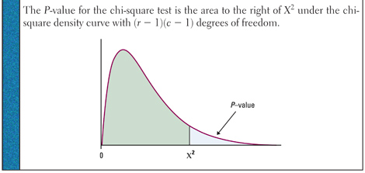
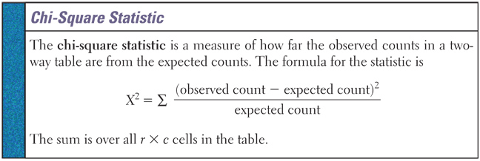
- Large values of χ² are evidence against H₀ because they say the observed counts are far from what we would expect if H₀ were true.
- Chi-Square tests are one-side (even though Ha is many-sided)
Example 1: Market researchers know that background music can influence the mood and purchasing behavior of customers. One study in supermarket in Northern Ireland compared three treatments: no music, French accordion music, and Italian string music. Under each condition, the researchers recorded the numbers of bottles of French, Italian, and other wine purchased. Here is a table that summarizes the data:

Music
Wine | None | French | Italian | Total
French | 30 | 39 | 30 | 99
Italian | 11 | 1 | 19 | 31
Other | 43 | 35 | 35 | 113
Total | 84 | 75 | 84 | 243

- Hypotheses:

- Conditions:

- Calculations:

- Interpretation:

Homework: Day 1: pg 866, 14.15 – 14.18

AP Tip: Writing out an entire χ² summation will be very time consuming (something you don’t have on the test)
To demonstrate to the AP reader that you have an understanding of χ² statistic write out statistic, definition, first and last terms and what’s its sum is

z-Test vs χ² test:
- We use the χ² test to compare any number of proportions
- The results from the χ² test for 2 proportions will be the same as a z-test for 2 proportions
- z-Test is recommended to compare two proportions because it gives you a choice of a one-side test and is related to the confidence interval for p₁ – p₂.

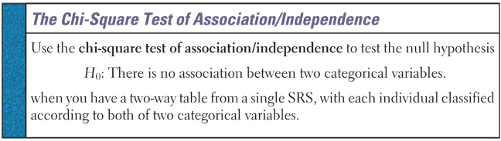
This test assesses whether this observed association is statistically significant. That is, is the relationship in the sample sufficiently strong for us to conclude that it is due to a relationship between the two variables and not merely to chance.

Example 2: Many popular businesses, like McDonald’s, are franchises. Some contracts with franchises include a right to exclusive territory (another McDonald’s can’t open in that area). How does the presence of an exclusive territory clause in the contract relate to the survival of the business? A study designed to address this question collected data from a sample of 170 new franchise firms. Here are the observed count data:

Exclusive Territory
Success | Yes | No | Total
Yes | 108 | 15 | 123
No | 34 | 13 | 47
Total | 142 | 28 | 170

- Hypotheses:

- Conditions:

- Calculations:

- Interpretation:

Homework: Day 2: pg 874: 14.21-14.23
Chapter 14: Review

Objectives: Students will be able to:
Summarize the chapter
Define the vocabulary used
Know and be able to discuss all sectional knowledge objectives
Complete all sectional construction objectives
Successfully answer any of the review exercises

Explain what is meant by a chi-square goodness of fit test.
Conduct a chi-square goodness of fit test.
Given a two-way table, compute conditional distributions.
Conduct a chi-square test for homogeneity of populations.
Conduct a chi-square test for association/independence.
Use technology to conduct a chi-square significance test.

Vocabulary: None new

Goodness of Fit Tests on TI
- Enter Observed values in L1
- Enter Expected values in L2
- Enter L3 by L3 = (L1 – L2)^2/L2
- Use sum function under the LIST menu to find the sum of L3. This is the value of the χ² test statistic
- Largest values in L3 are the observations that are the largest contributors to the total value

Homogeneity and Independence Tests on TI:
- Press 2nd X⁻¹ (access MATRIX menu)
  - Arrow to EDIT and select 1: [A]
- Enter the number of rows and columns of the matrix
- Enter the cell entries for the observed data and press 2nd QUIT
- Press STAT, highlight TESTS and select C: χ²-Test
- Matrix [A] (and Matrix [B] for expected) are defaults
- Highlight Calculate and press ENTER
- Highlight Draw and the χ² curve will be drawn, the critical area in the tail shaded and the p-value displayed
- If you need the expect counts display Matrix B from the matrix menu

Homework: pg 882 - 84: 14.35-37, 14.39-43

